Ecopath Model from Ecosim
With this functionality, it is now possible to create new Ecopath models in v6 from specific Ecosim years. This functionality was previously included in EwE v5. The novel capability of the tool is the ability to choose a biomass accumulation calculation (see above).
The model is created from the first time step (January) of a specific Ecosim year set by the user.
Steps to use this functionality:
1. Navigation tree > Ecosim > Tools > Ecopath model from Ecosim.
2. Enable the plug-in by clicking the box “Enable model generation”.
3. Choose a biomass accumulation (BA) calculation method.
4. Choose the output path where new model(s) will be saved.
5. Check the years for which models are to be generated (Figure 1).
The tool automatically proposes file names based on the Ecopath model name and the selected year (Figure 1). This name can be overridden manually. To revert to a default file name simply clear the model name field.

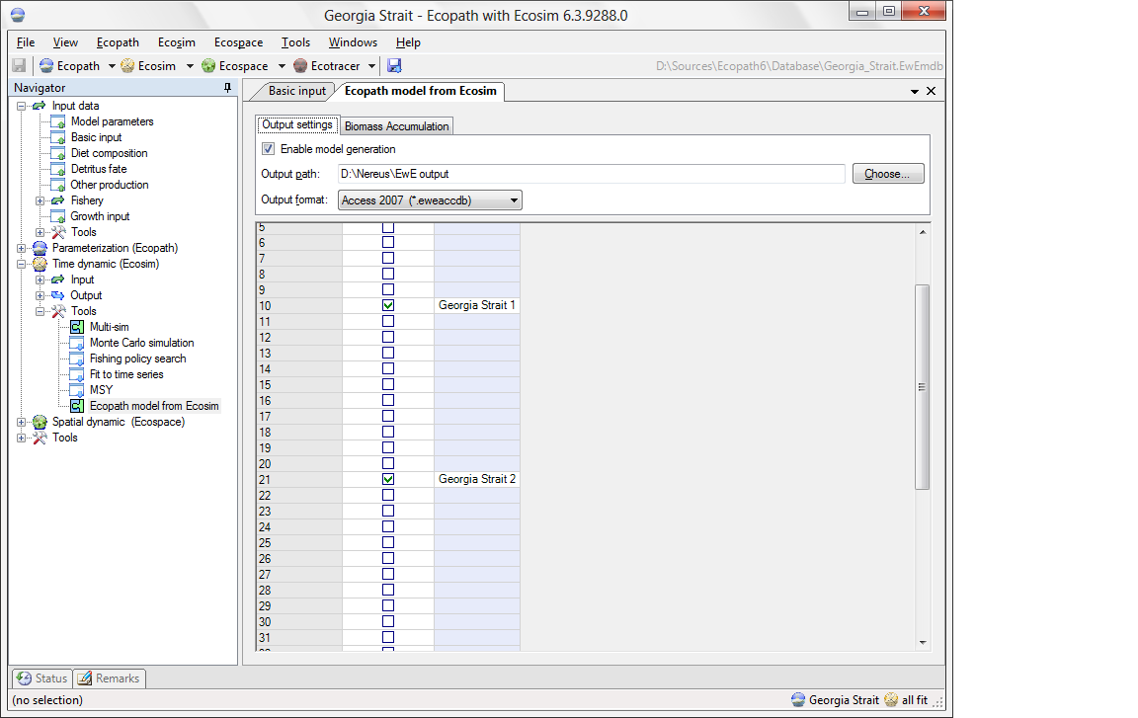
Figure 1.
Options for biomass accumulation (BA) calculation method (Figure 2):
- Average Ecosim biomass change over a number of years
This method calculates BA by averaging the biomass change over the number of years established in the tab “Nº of years for averaging BA” (Figure 3). If the nº of years established are larger than the number of years previous to the selected year to create the model (Figure 3), then the average is performed over the shorter period.
- Distance weighted average Ecosim biomass over years
This method performs the same calculation as the first one, but uses the distance weighting power to exponentially down weight the contribution from older years (Figure 3). In this case, with exponentially decaying weighting terms, the contributions from further back in time are dulled. Users need to select the number of years for averaging BA from the box below as well as a distance weighting power from the second box below).
- Ecopath biomass accumulation value
This method provided the initial values of BA in the Ecopath model.
- Ecosim biomass minus Ecopath biomass
This method calculates the Ecosim biomass at the time step of creation of the new model minus the Ecopath biomass using the values at the beginning of the simulation.
- No biomass accumulation (BA = 0).
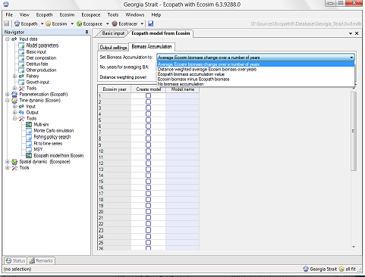
Figure 2.
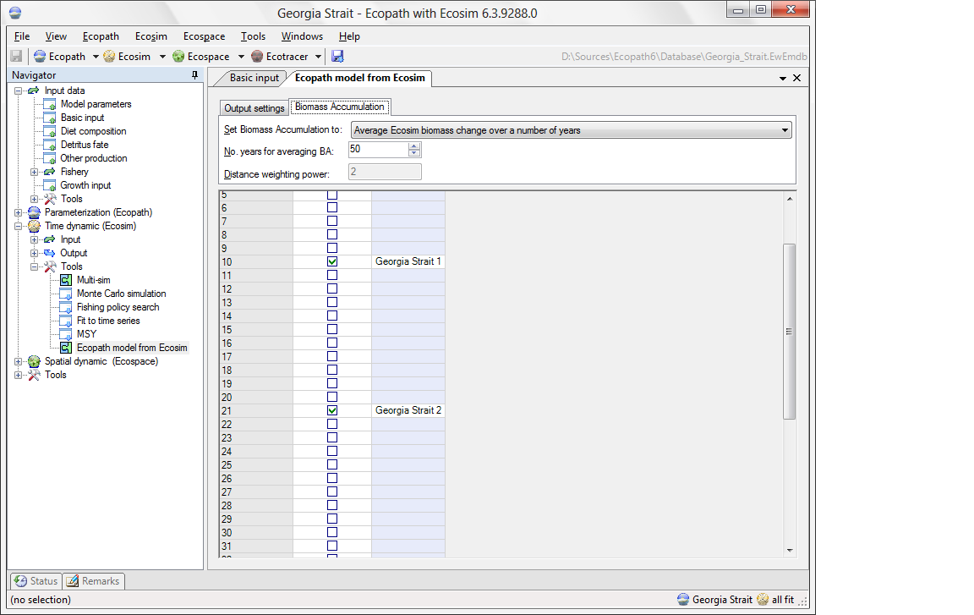
Figure 3.
Things to consider when generating new models from Ecosim time steps:
Biomass accumulation is the difference between the biomass for a given trophic group from one year to the next. Default biomass accumulation is 0 indicating no biomass accumulation. A negative value indicates biomass depletion. BA can be a flow term with a rate unit (y⁻¹) (biomass accumulation rate) or absolute values (with units as t·km⁻²·y⁻¹, for example) (biomass accumulation value)
Any model that is generated from an Ecosim time step will not necessarily be balanced due to Ecosim dynamics and BA.
Models will be generated for the first time step of an Ecosim year (January).
Internals
A newly generated Ecopath model inherits group, fleet, and multi-stanza configurations from the parent model. In the current incarnation in EwE version 6.4, pedigree, taxa, and entered remarks are not transferred from the parent model.
Most functional group and fleet settings in the new model are copied from the parent Ecopath model, with exception of a few input values that are calculated as follows:
B*_{i} = B_{it}
Ex*_{i} = Catch_{fit}
PB*_{i} = Loss_{it} / B_{it}
QB*_{i} = TotalConsumption_{it} / B_{it}
EE*_{i} is cleared
Emig*_{i} = EmigRate_{i} · B_{it}
Barea*_{i} = B_{it} / Area_{i}
DC*_{ji} = Consumption_{jit} / TotalConsumption_{jt}
Landings*_{fi} = Landings_{fi} · TotalCatch_{fit} / Catch_{fi}
Discards*_{fi} = Discards_{fi} · TotalCatch_{fit} / Catch_{fi}
Where i indicates a group or prey, j indicates a predator, and f indicates fleet, and t the time step in the parent model. Variables marked * indicate a value in the new model. Ex = export, B = biomass, PB = Production / Biomass rate, QB = Consumption / Biomass rate, EE = Ecotrophic efficiency, Emig = emigration, Barea = biomass per unit of area, DC = Diet Compostion.

